Design Fundamental
Design is a decision making process where an idea is produced.
Basic principles of design:
Here are eight basic design principles to keep in mind when working with visuals and creating graphics.
- Alignment. ...
- Hierarchy. ...
- Contrast. ...
- Repetition. ...
- Proximity. ...
- Balance. ...
- Color. ...
- Space.

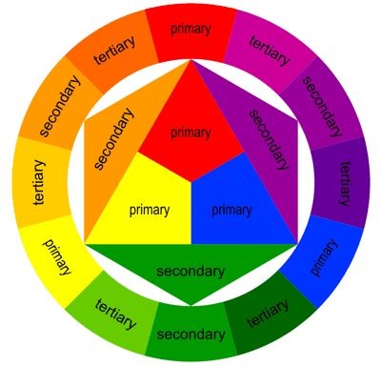
Colour Wheel
A color wheel or colour circle is an abstract illustrative organization of color hues around a circle, which shows the relationships between primary colors, secondary colors, tertiary colors etc.
Some sources use the terms color wheel and color circle interchangeably; however, one term or the other may be more prevalent in certain fields or certain versions as mentioned above. For instance, some reserve the term color wheel for mechanical rotating devices, such as color tops or filter wheels. Others classify various color wheels as color disc, color chart, and color scale varieties.

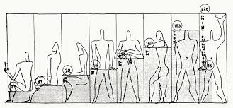
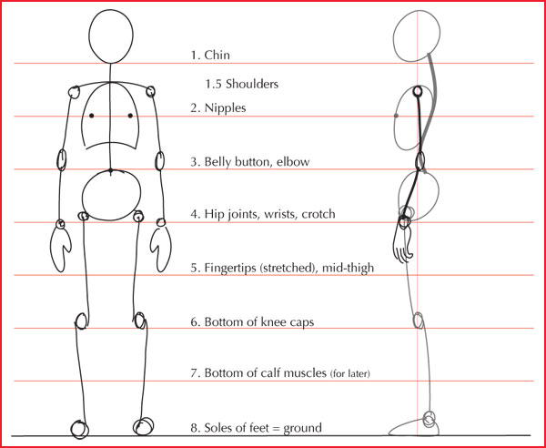
Human Figure
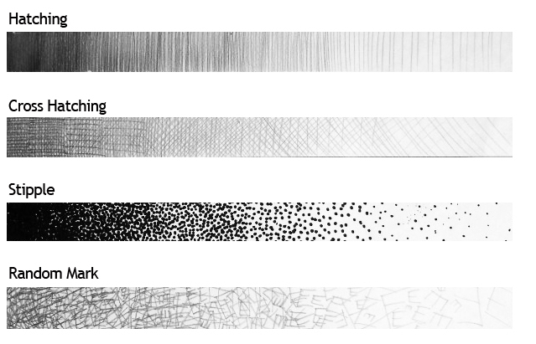
Shading and hatching

Isometric drawing:

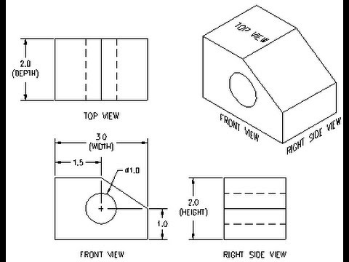
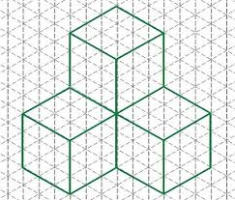
Isometric projection is a method for visually representing three-dimensional objects in two dimensions in technical and engineering drawings. It is an axonometric projection in which the three coordinate axes appear equally foreshortened and the angle between any two of them is 120 degrees.

Architectural Graphics

Fonts Scale architecture drawing
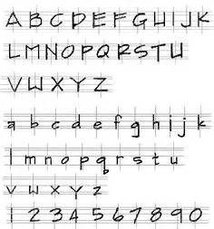
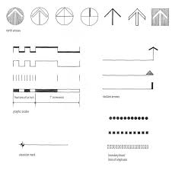

Textures
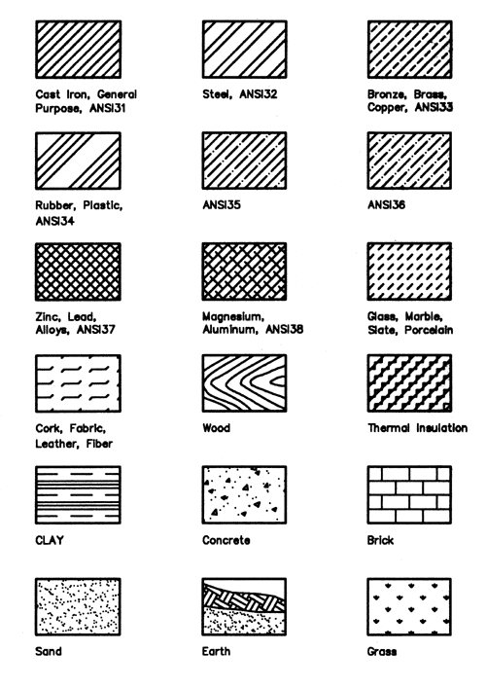
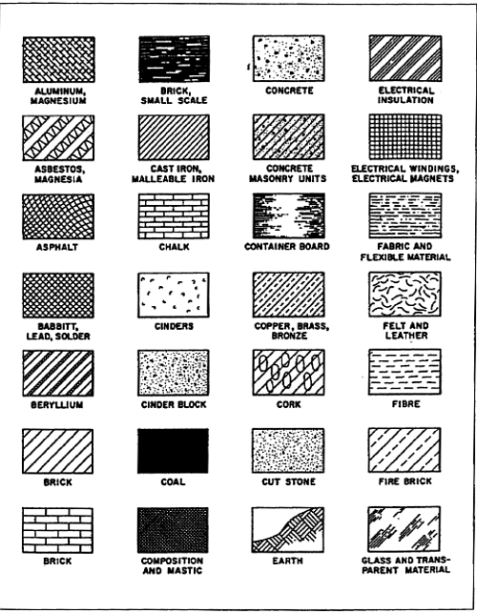

Symbolic representations
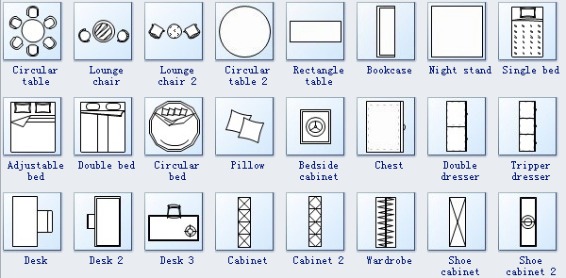
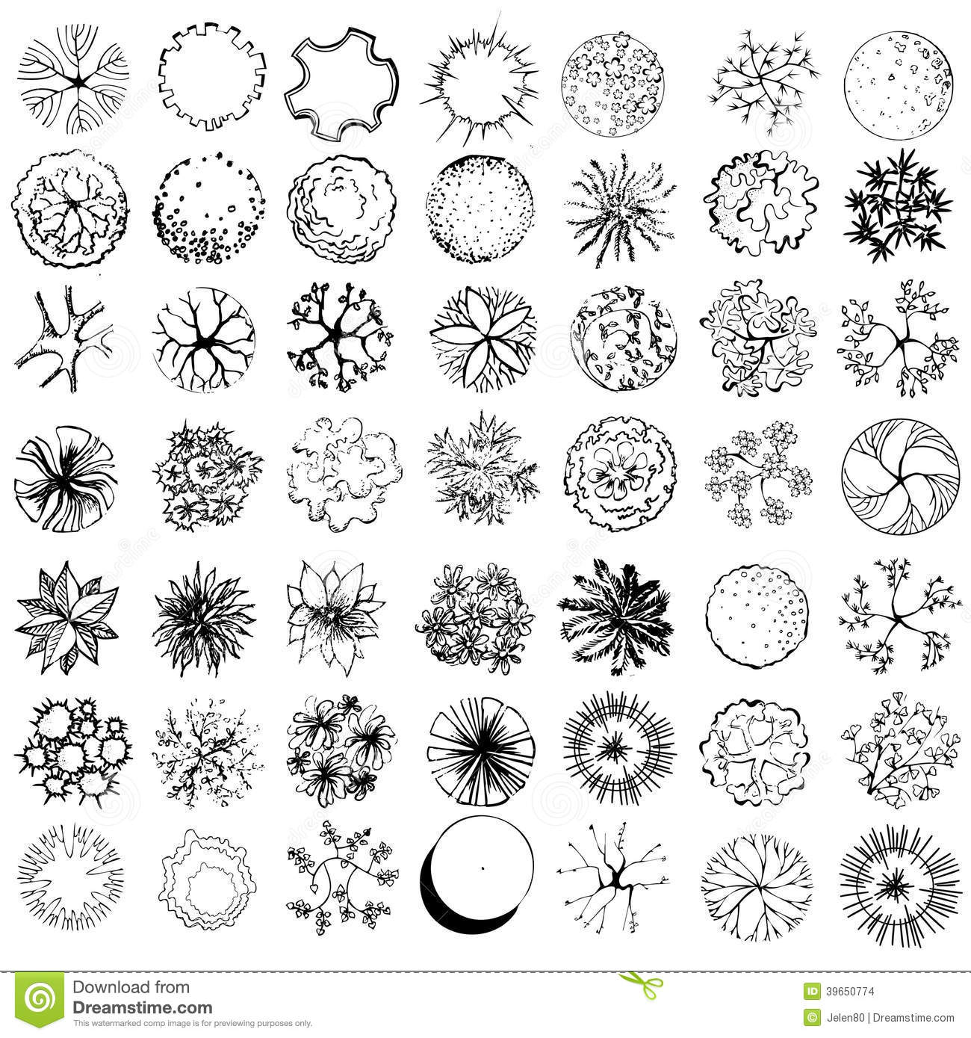
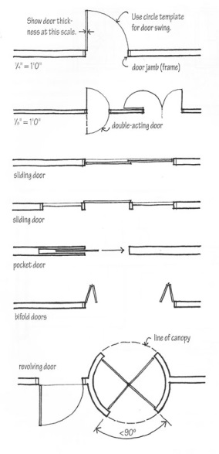

Digital Graphics

- PHOTOSHOP
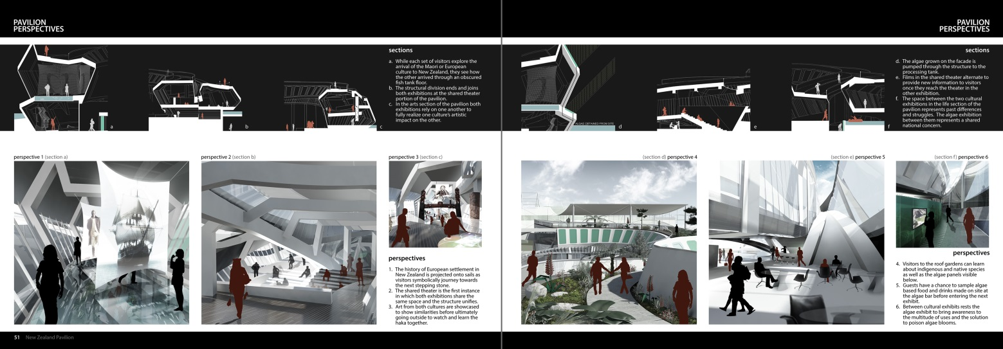
Used to design architectural portfolio in a more professional way. Helps to create a more attractive presentation for clients.
- AutoCAD
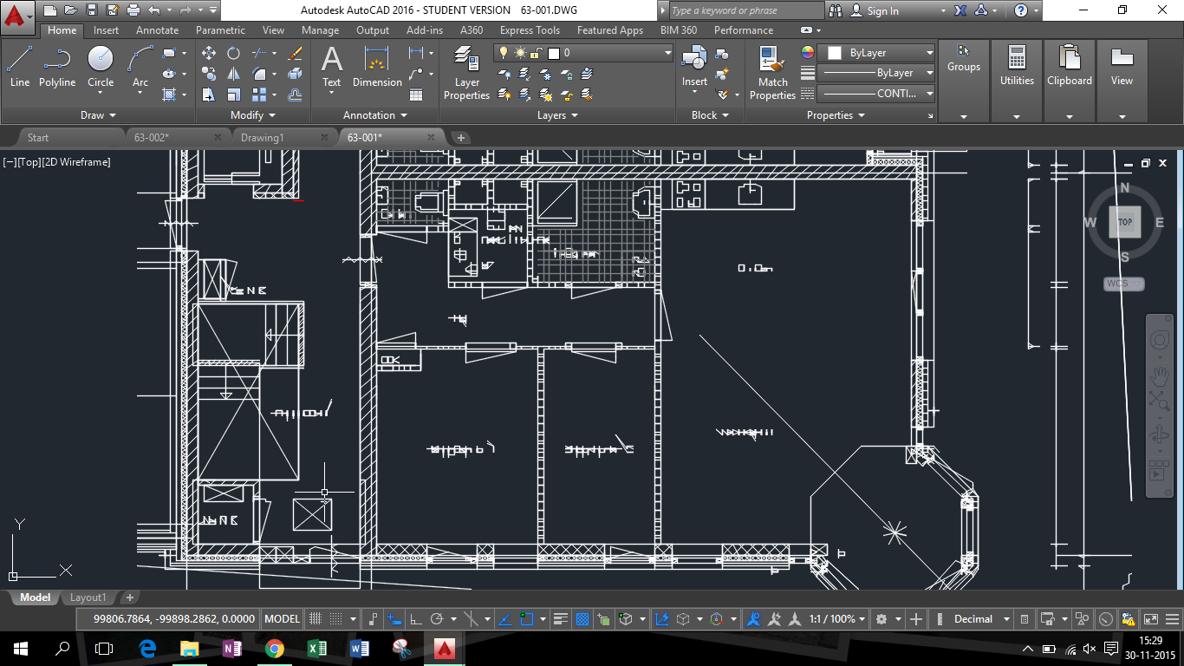
AutoCAD is a commercial computer-aided design (CAD) and drafting software application. AutoCAD is used across a wide range of industries, by architects, project managers, engineers, graphic designers, and many other professionals. It was supported by 750 training centers worldwide in 1994.
- SketchUP
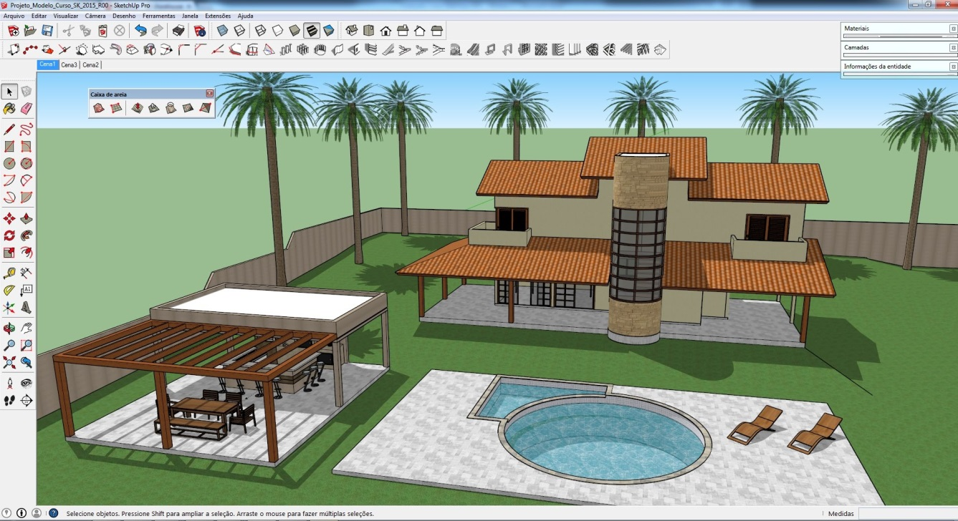
SketchUp, formerly Google Sketchup, is a 3D modelingcomputer program for a wide range of drawing applications such as architectural, interior design, landscape architecture, civil and mechanical engineering.
- 3D Max( AutoDesk App)
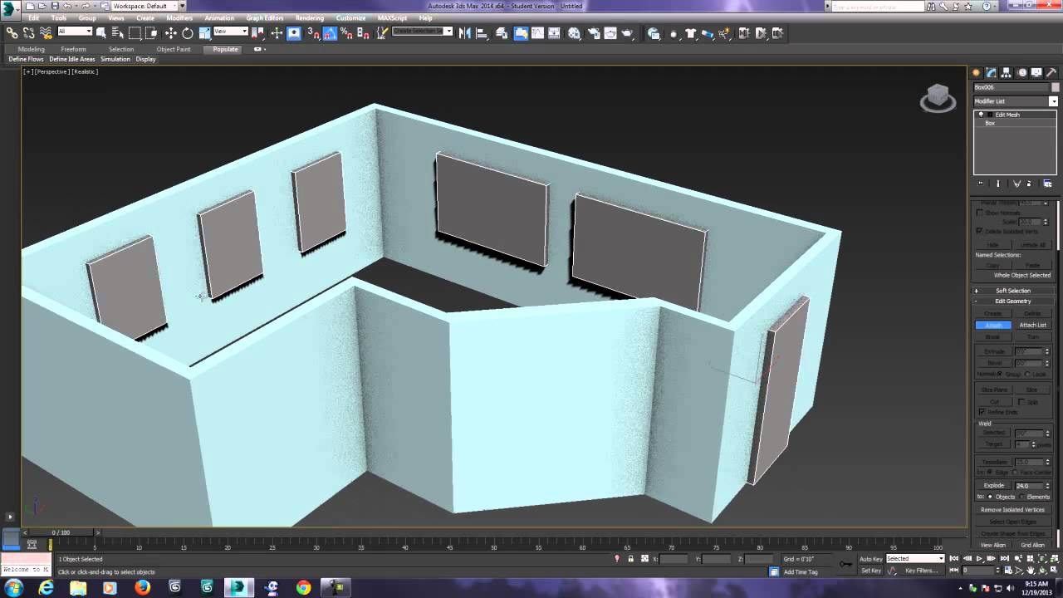
Autodesk 3ds Max, formerly 3D Studio and 3D Studio Max, is a professional 3D computer graphics program for making 3D animations, models, games and images.

Architectural Standards
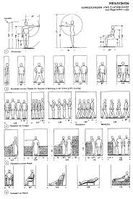
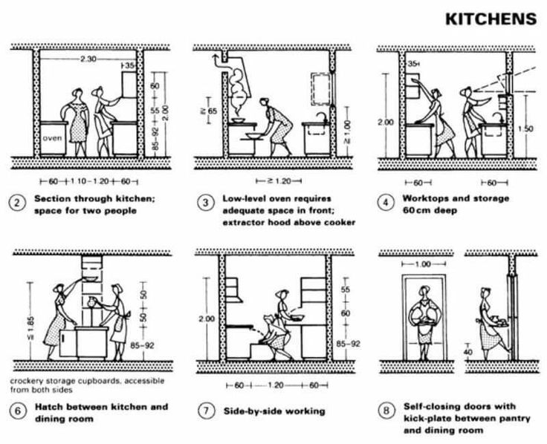
Neufert is the book of standards that all architects around the world use as it consists of all standard dimensions of an object used everywhere.

Free hand Drawing
- One point Perspective
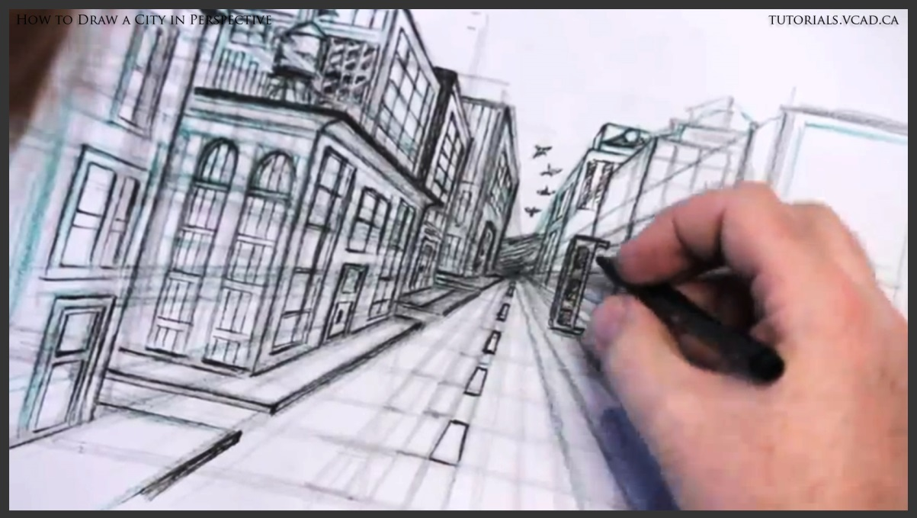

- Two point Perspective
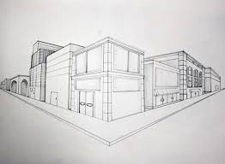

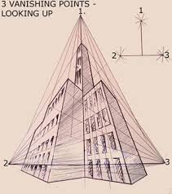
- Three Point Perspective

- Shading
