Learning Enhancement Center (LEC)
Online Appointment Process

Students, faculty, and employees are encouraged to reserve online appointments for academic support at the Learning Enhancement Center by following procedures 1~8 listed below. To access the LEC online appointment process, select one of the following methods for your convenience:
- UoN website (www.unizwa.edu.om) click on “Students” then click on TWC’s logo or Useful Links then click on Registration on Learning Enhancement Center.
- From any computer terminal on the UoN campus, input into your web browser “cis/twc”.
- From your mobile device using UoN Wi-Fi input into your web browser “http://cis/twc”.
Step 1: Login
- Input your user name (Same name to access computers across campus)
- Input your password (Same password to access computers across campus)
- Press “Login” when finished
Step 2: Homepage
From the homepage, visitors can view an official record of their appointments, reserve a new appointment, upload supporting materials, and view LEC’s timetables related to all programs and services offered by LEC.
- To make an appointment at LEC click the box “Appointment Booking”.

Step 3: LEC Learning Enhancement Center
Select “LEC” if you require academic support in Mathematics, Engineering, Science, Design, Business or Computer subjects.
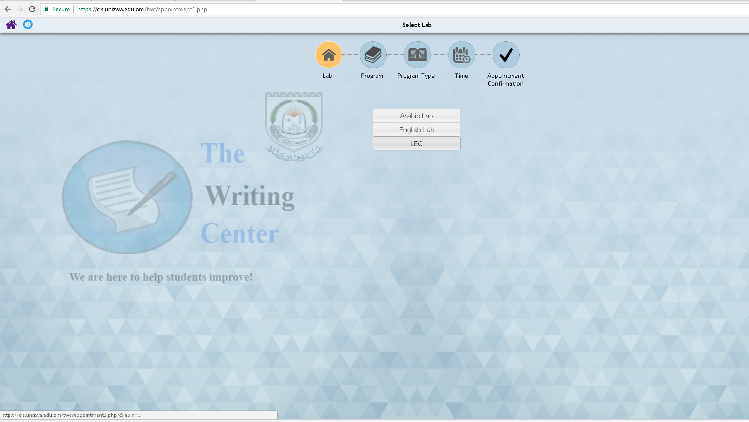

Step 4: LEC Programs and Services

- Select “Course Subject” if you require academic support in any one of these subjects:

Step 5: Name of Course
- Select the name of course required for the subject that you have previously chosen in step 4.
- This is an example of the drop down menu for a selected subject.

Step 6: Appointment Scheduling
- Select the date and time of your appointment. (Grey = Not Available Gold = Available)

Step 7: Confirmation Booking
- Confirm your proposed appointment booking.
- Read the Rules for Students Visiting LEC and select the box.
- Select “Register”.
(Lab, type of appointment, type of service, date, and time)
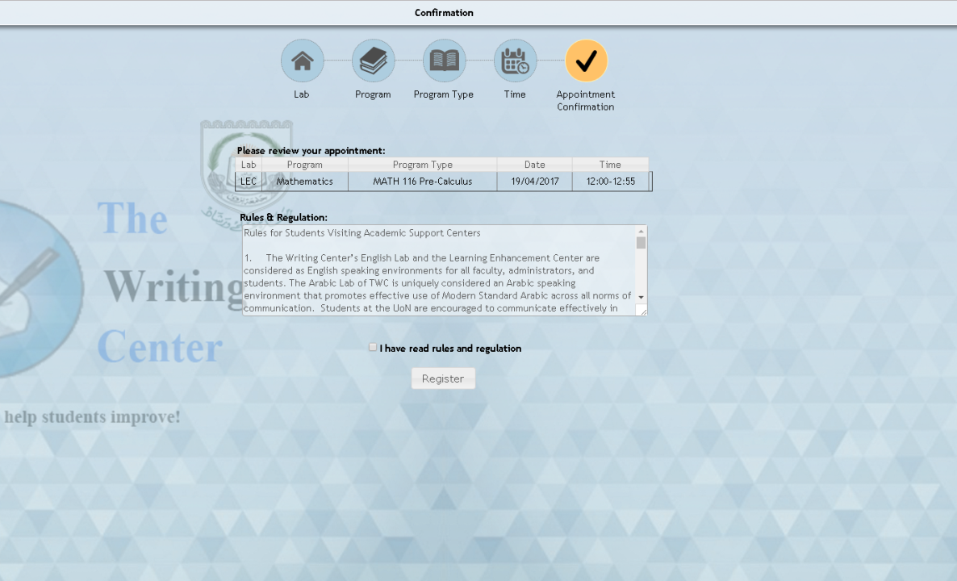

Step 8: LEC Appointment Reserved
- Your appointment has been successfully reserved at LEC.
- An automated email has been sent to you as a reminder of your appointment at LEC.
- Kindly logout on the upper right corner or make another appointment.

Appendix 1: Student Appointment Record and Cancellation Process
- Click on the Homepage box labeled “My Appointments” to view an official record of the appointments that you reserved and attended at LEC. This information is practical for students that need to provide evidence to their academic advisors or course instructors that the student has successfully sought quality academic support.

- If you are not able to keep your reserved appointment for any reason, kindly cancel the appointment from this page at least one hour before it is scheduled to start. Failure to responsibly cancel appointments twice (2) in a month will result in temporary blockage of your account.

- Please visit in person to have your account unblocked for future usage.

- Select the “X” to cancel previous scheduled appointments.

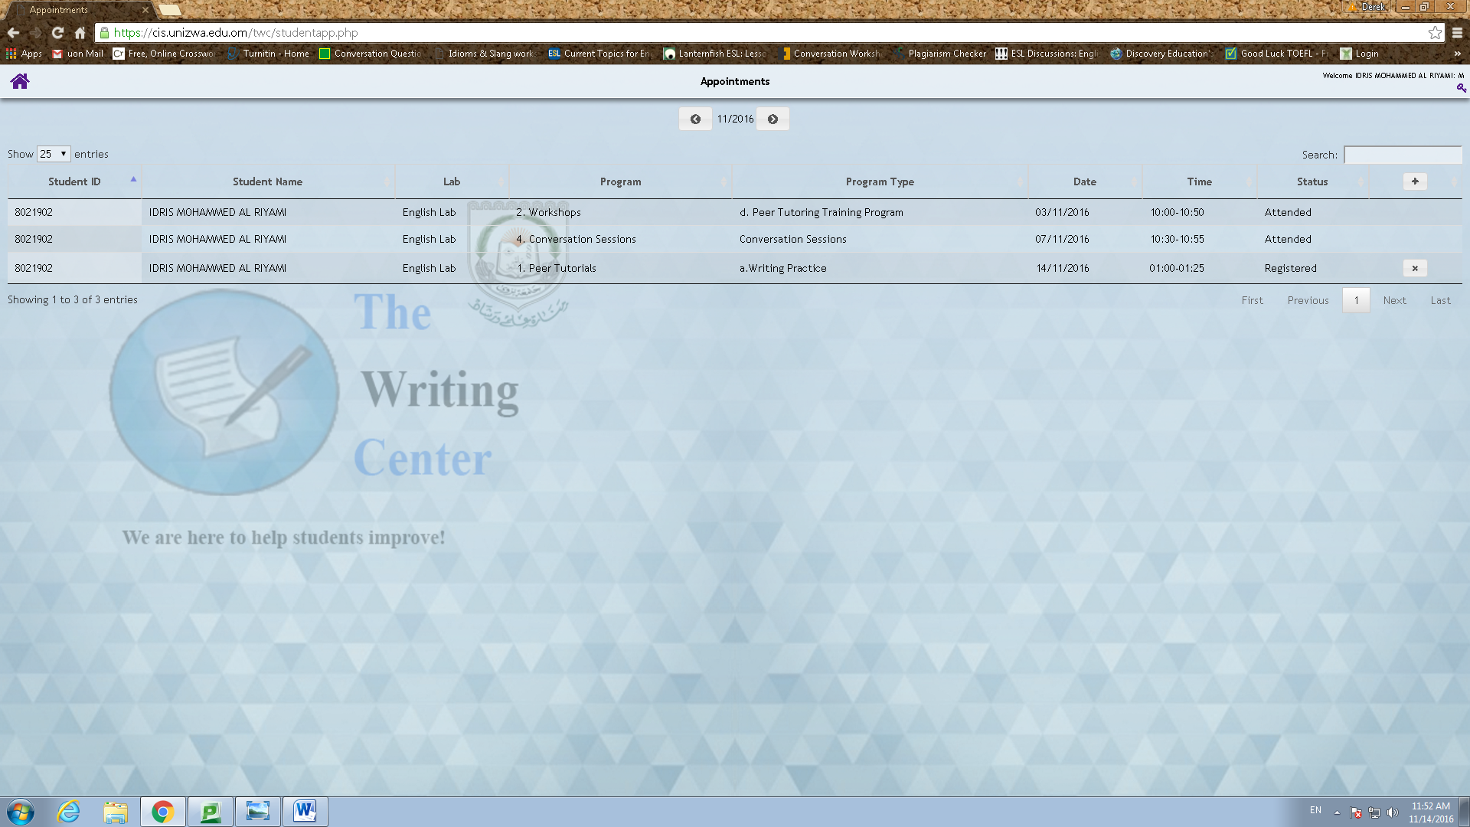

Thank you for visiting LEC

