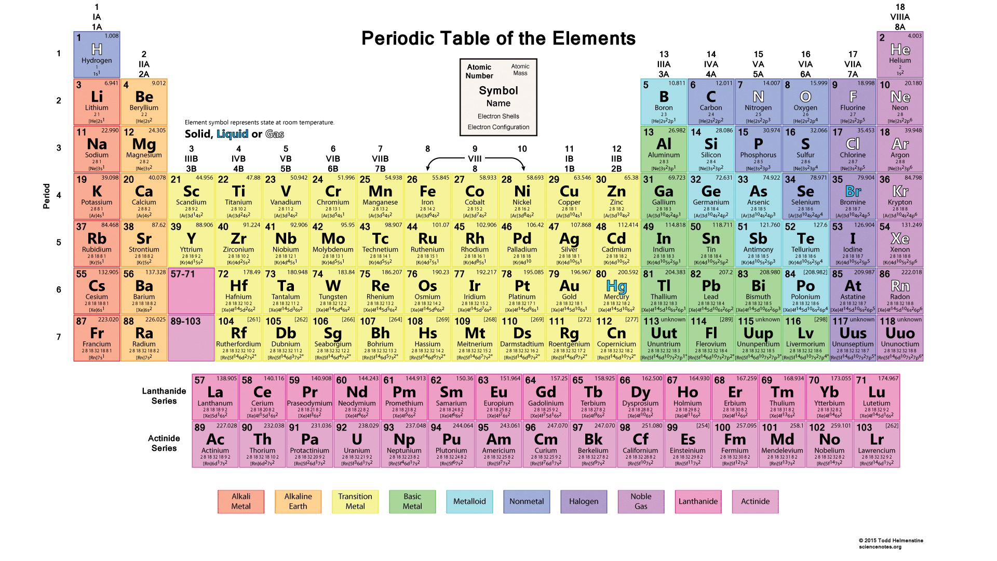
General Chemistry

Balancing Chemical Equations
A chemical equation shows the chemical formulas of substances that are reacting and the substances that are produced. The number of atoms of the reactants and products need to be balanced. In this lesson, we will discuss balancing chemical equations.

Let's take a look at an equation representing a chemical reaction:
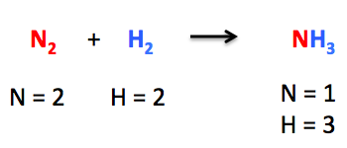
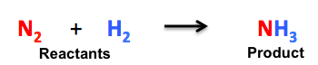
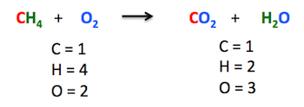
Example: This is a reaction between methane (CH4) and oxygen (O2), producing carbon dioxide (CO2) and water (H2O).
