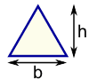 | Triangle  Area = ½ × b × h  b = base  h = vertical height |  | 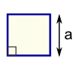 | Square  Area = a²  a = length of side
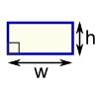 | Rectangle  Area = w × h  w = width  h = height |  | 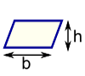 | Parallelogram  Area = b × h  b = base  h = vertical height
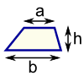 | Trapezoid (US)  Trapezium (UK)  Area = ½(a+b) × h  h = vertical height |  | 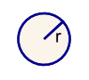 | Circle  Area = π × r²  Circumference = 2 × π × r  r = radius
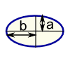 | Ellipse  Area = πab |  | 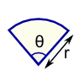 | Sector  Area = ½ × r² × θ  r = radius  θ = angle in radians
Area of Plane Shapes

Volume Formulas
cube = a ³ 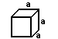
rectangular prism = a b c 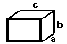
irregular prism = b h 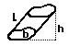
cylinder = b h = pi r ² h 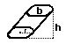
pyramid = (1/3) b h 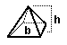
cone = (1/3) b h = 1/3 pi r ² h 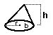
sphere = (4/3) pi r ³ 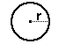
ellipsoid = (4/3) pi r₁ r₂ r₃ 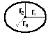

Properties of Exponents
1. xa xb = xa+b Examples: x3 x2 = x5, x1/2 x1/3 = x5/6, x3 x 1/2 = x5/2

2. xa xb = xa b Examples: x5 x3 = x2, x3 x5 = x 2, x3 x1/2 = x5/2

3. (xa)b = xab Examples: (x3)2 = x6, (x 1/2)7 = x 7/2, (x2/3)5/7 = x10/21

