HTML programs
HTML: Hypertext markup language (HTML) is the major markup language used to display Web pages on the Internet. In other words, Web pages are composed of HTML, which is used to display text, images or other resources through a Web browser. All HTML is plain text, meaning it is not compiled and may be read by humans. The file extension for an HTML file is .htm or .html
Program #1 :creating different bullets style
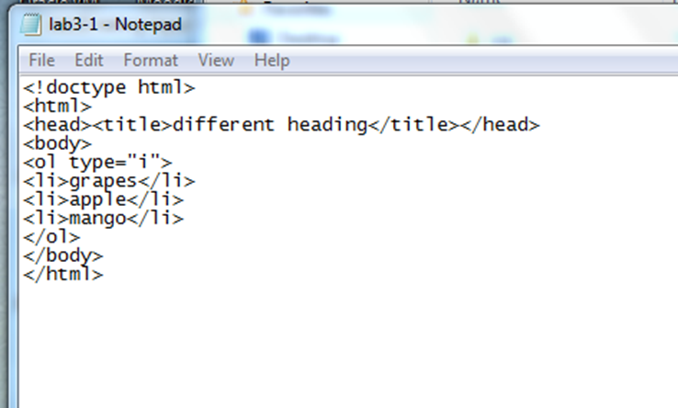
Output
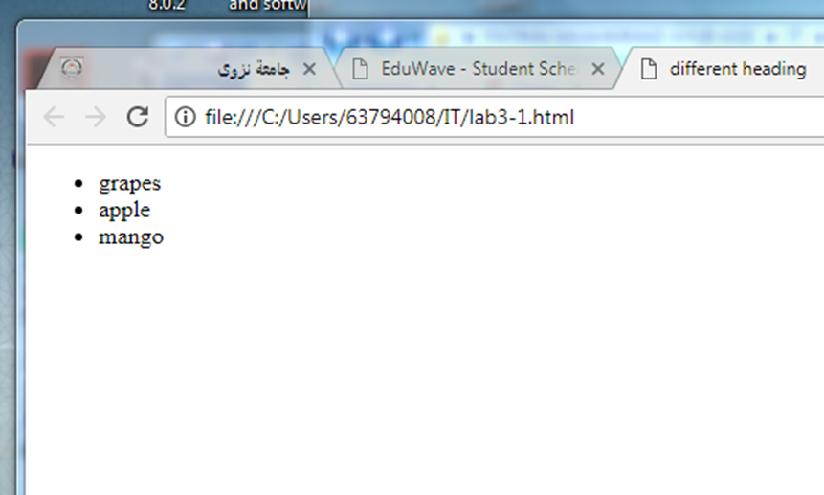

Program #2 : creating different bullets style
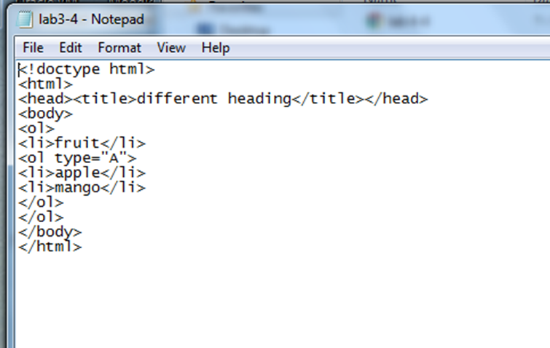
Output
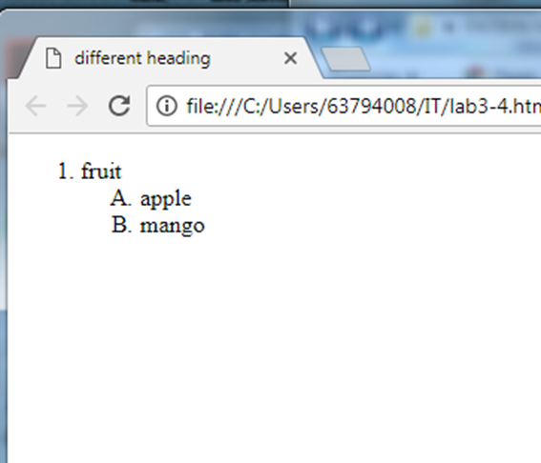

Program #3 : creating table
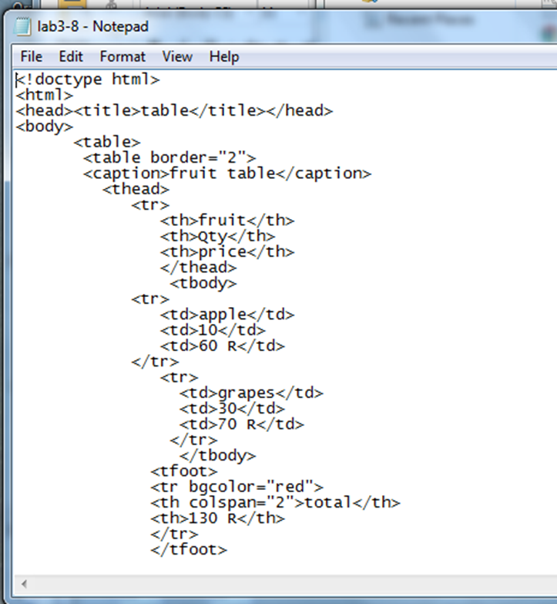
output

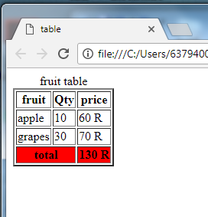

Program #4 : creating table
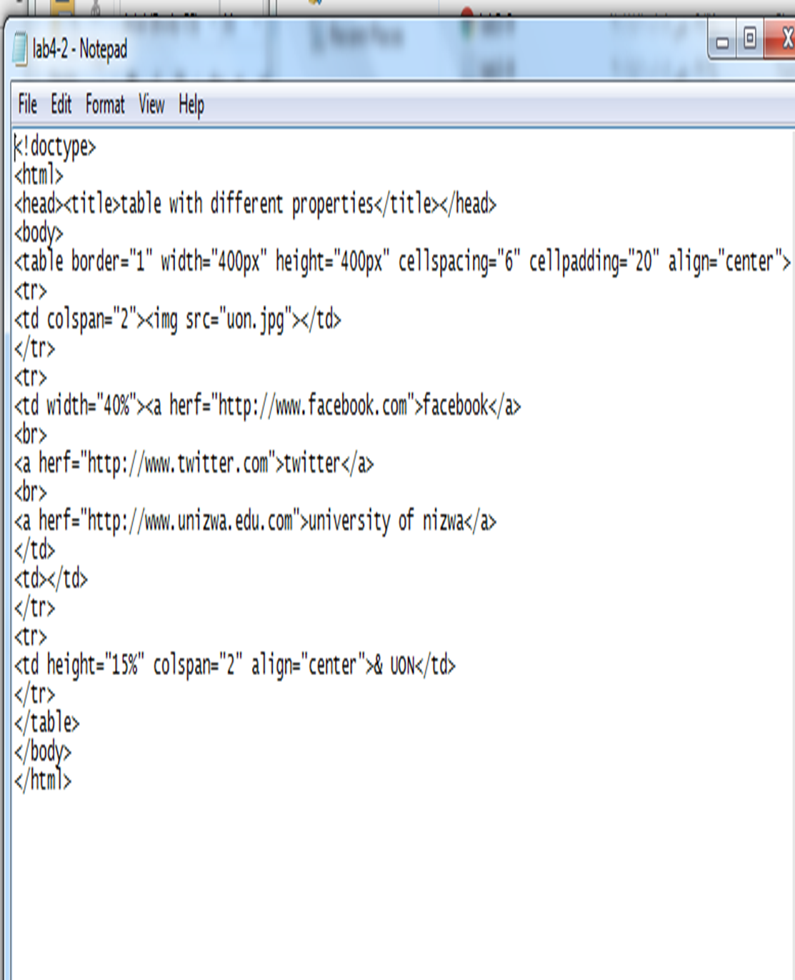
Output
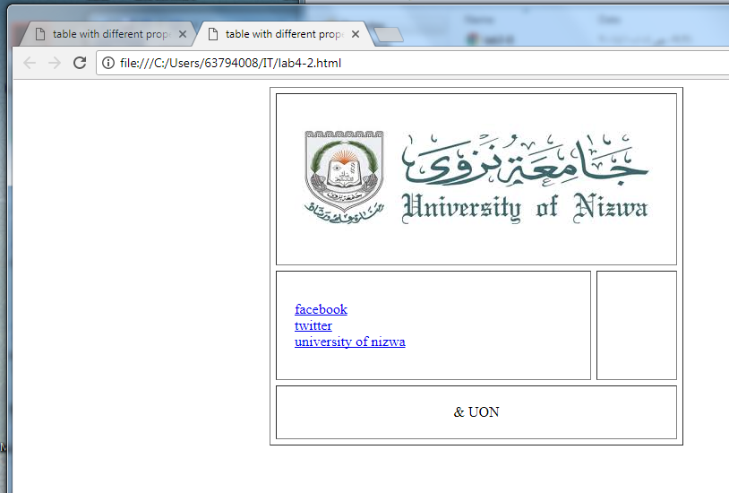

Program #5: creating table
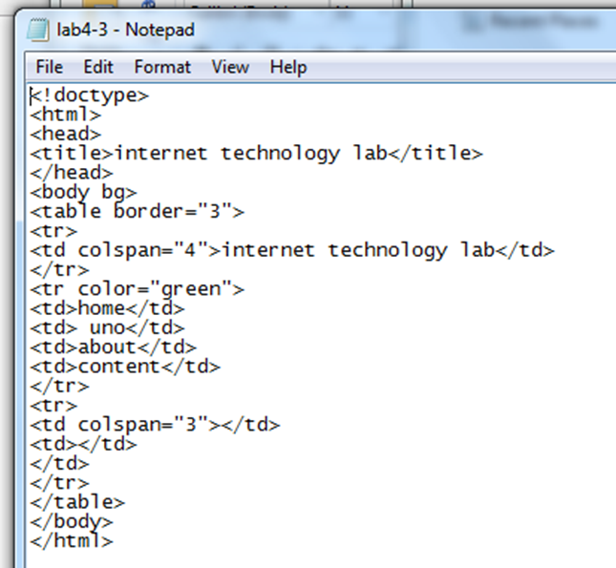
Output
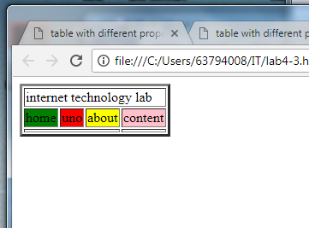

Program #6 : creating form
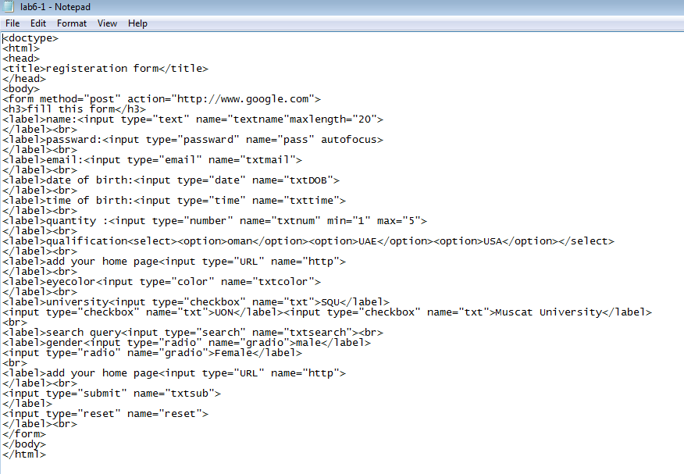
Output
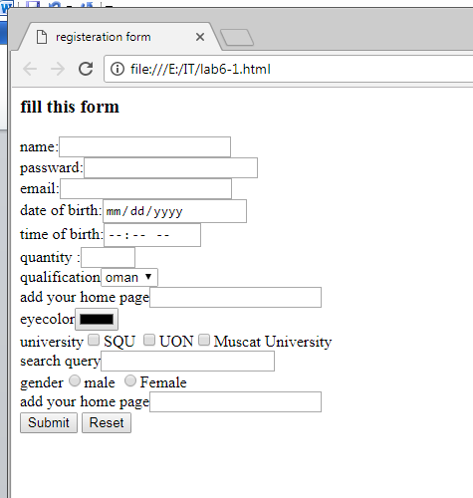

CSS program
CSS: Cascading Style Sheets (CSS) is a standard (or language) that describes the formatting of markup language pages. CSS enables developers to separate content and visual elements for greater page control and flexibility. A CSS file is normally attached to an HTML file by means of a link in the HTML file.
There are three types of css
1.internal CSS : this is written in the body
2. embedded CSS : the codes are written in the head section
3. external CSS : written in the different file and saved with .css extension
Program #7 : inline CSS
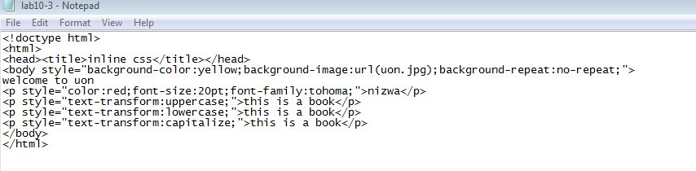
Output
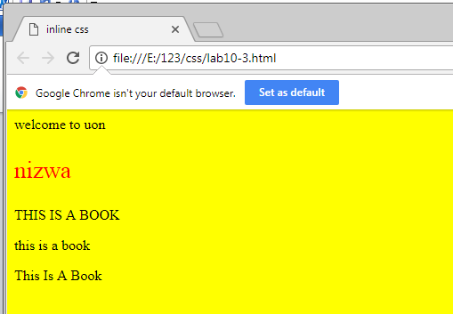
Program #8 :embedded CSS
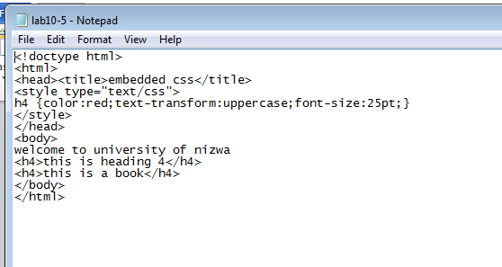
Output
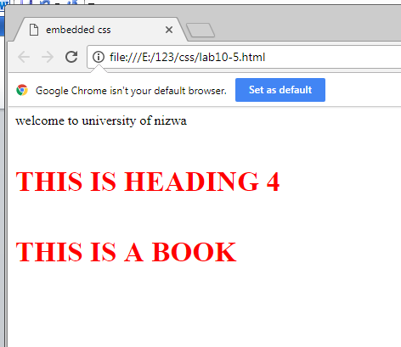

Program #9:external CSS
NOTE:SAVE THIS FILE WITH THE EXTENSION .CSS
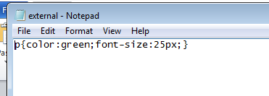
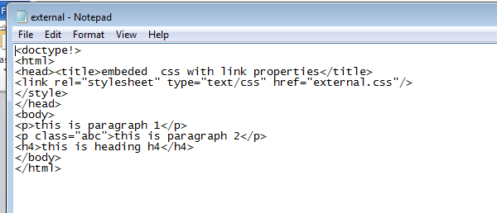
Output
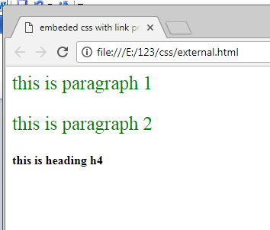
JavaScript: Javascript (JS) is a scripting languages, primarily used on the Web. It is used to enhance HTML pages and is commonly found embedded in HTML code. JavaScript is an interpreted language. Thus, it doesn't need to be compiled. JavaScript renders web pages in an interactive and dynamic fashion.
Program # 10 : sum of two numbers
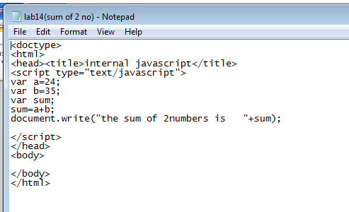
Output
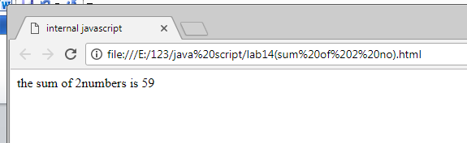

Program # 11 :while loop / for loop
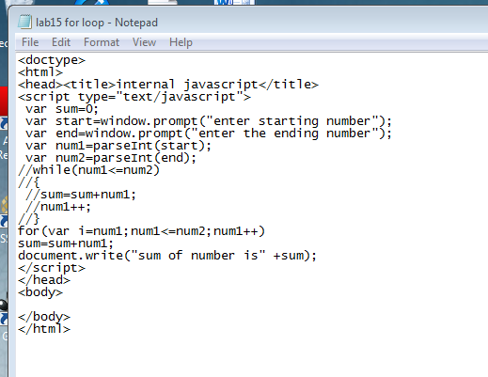
Output
