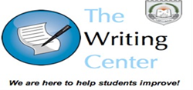
Topic:
Visual Warmer: Discuss the following images together as a group.

Survey/Quiz: Answer the following questions by indicating yes/no. Then discuss your answer with the group.
Questions | YES | NO

Vocabulary: Listen to your instructor provide definitions and examples for each of the following words. Try to apply the new vocabulary in the proper context as much as possible.
Idiomatic Expressions:

Discussion Questions: Answer the following questions as a group and then ask additional follow-up questions

